* **Installation Process**

Download the ([Oracle Database 11g Express Edition](https://www.oracle.com/database/technologies/xe-prior-release-downloads.html)) and install the software. Remember the password you set during the installation because this password is needed later.

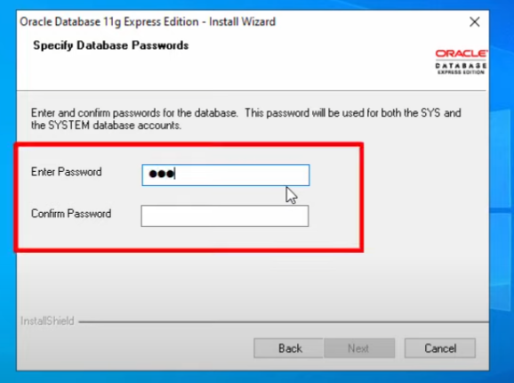

After the completion of installation, open **Run SQL Command Line** and write 'connect system' and use the password that you set in the installation process. Follow the below figure.

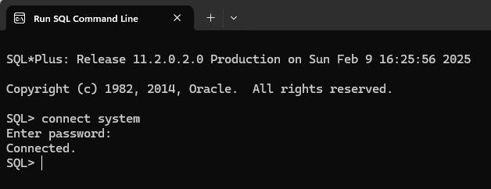

If you forget the password, you can set a new one for the 'system' user using these commands:

connect / as sysdba

alter user system identified by [password];

* **Creating Users and Giving System Privileges**

Create a user:

create user waliul034 identified by 1807034;

Delete any user:

drop user [username];

Grant system privileges to a user:

grant all privileges to [username];

Revoke all the privileges from a user:

revoke all privileges from [username];

Grant a specific privilege to a user:

grant create session to [username];

Revoke a specific privilege from a user:

revoke create session from [username];

Create a role:

create role manager;

grant create table, create session to manager;

grant manager to waliul034;

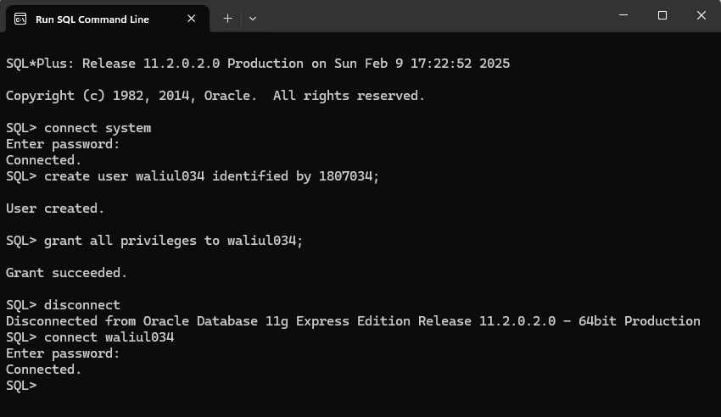

Show and set line size and page size:

show pagesize

show linesize

set pagesize 100

set linesize 200

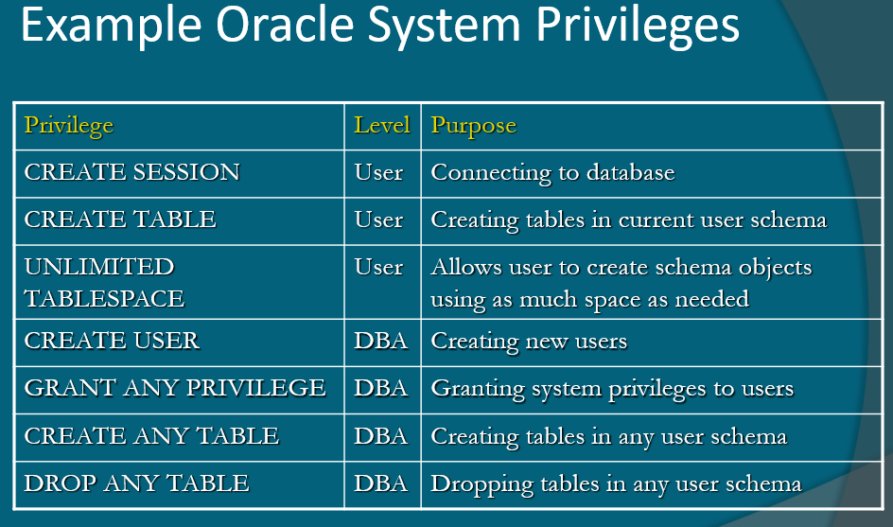

* **Working with Tables: Creation and Operations**

Create a simple table:

create table test(

id number(3),

name varchar(20),

mark number(3,2)

);

You can learn about different data types [here.](https://www.w3resource.com/oracle/oracle-data-types.php)

View table description:

describe test;

Insert some data into the table:

insert into test (id, name, mark) values (1, 'Abc', 8.32);

insert into test (id, name, mark) values (2, 'DEF', 6.32);

View table data:

select * from test;

Check current username:

show user;

Check the existing tables in the database:

select table_name from user_tables;

Delete a table from the database:

drop table test;

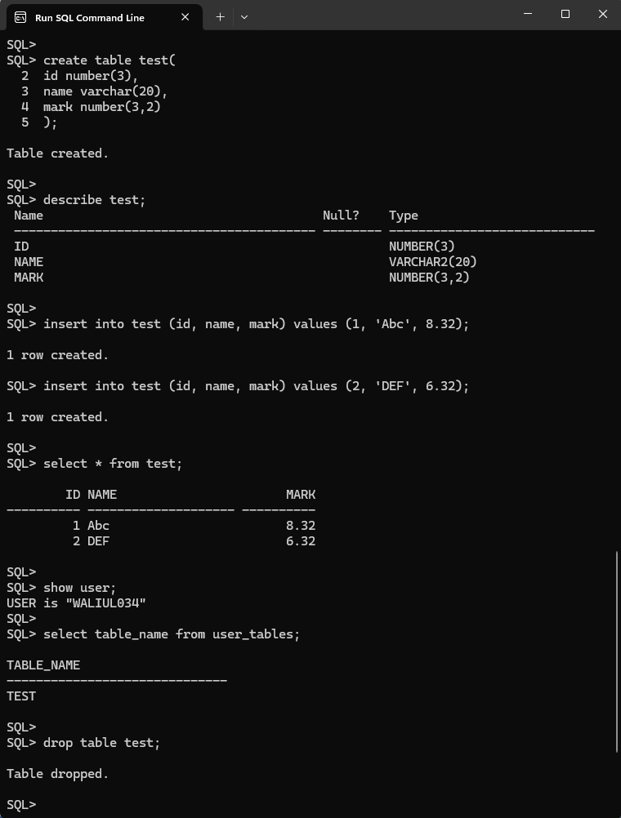

Run SQL commands from a file:

You can run SQL scripts using the SQL command line. You can write your SQL commands in a text file and save it with a ‘.sql’ extension (though this is not mandatory).. Then, type the below command:

start “G:\CSE 3110 (Database Systems Laboratory)\test_table.sql”

**THE END**